(Approx. 365 words)

Streaming Media
By Len Nasman, Editor, Bristol Village Computer Club, OH
October 2015 issue, BVCC Newsletter
www.bvres.org

Streaming Media refers to the process of receiving either audio or video files on a computer, TV, or a portable device. If you have watched a YouTube video on your computer, you have used streaming video.

Streaming Media is different from listening to, or watching something, from a CD, DVD, hard drive, flash drive or other locally stored file.

Streaming Media requires a live connection to the Internet.

In the case of Streaming Video, it is becoming popular to stream the video directly to a TV set. This requires both a TV set capable of connecting to the Internet, or an adapter (such as the Roku, or Google Chromecast), and a wireless access point. The ISP, Internet Service Provider (such as the Time Warner option here in Bristol Village) must have a speed rating of more than 4Mbps.

A Smart TV is capable of receiving streaming video as long as it has a wireless Internet signal available. Smart TV prices have come down along with the prices of flat screen TV's in general. I have seen 24 inch smart TV's advertised for less than $200, and there are deals on 40 to 55 inch models for under $700.

OK, say you have access to streaming video either through a smart TV or an Internet connected computer. The next step is to locate the media you want to stream.

In the case of streaming audio, there are many sites with links to radio stations that stream their programming.

As I am writing this, I am listening to Scheherazade by way of a Chicago classical radio station. Here are links to some streaming audio sites.
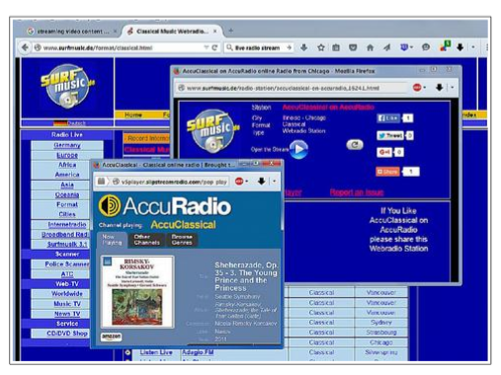

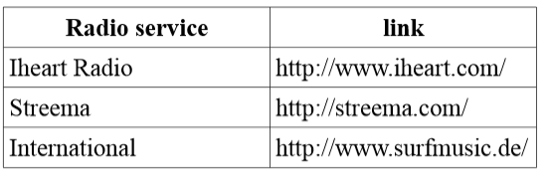

By the way, the Streema site also links to TV stations around the world.

If you are an Internet surfer, you probably know how to find free YouTube videos. If you want to stream the latest movies, and are willing to pay a fee, there are streaming video services available. You can stream to computers or portable devices. Here is a link to an article that reviews some of the popular streaming movie services.
http://www.digitaltrends.com/movies/best-media-streaming-sites-services

